Case Study : Preventive Asset Maintenance (PAM)

The water company in the East of England operates treatment sites, pumping stations, and storage facilities across more than 8,000 locations. Its extensive network of over 110,000 kilometers of pipes supplies clean water to 2.1 million properties and collects wastewater from 2.7 million properties.

The Challenge & Opportunity

With its extensive network of clean and wastewater pipes, the water company seeks to identify assets most at risk of supply interruptions. Additionally, it aims to leverage emerging technologies to improve efficiency in its current network management processes.

Organizations across all industries face growing pressure to increase shareholder value, and the expectations are particularly high in customer-focused sectors like hospitality. Industrial companies strive to improve profitability, reduce costs, enhance safety, and minimise unplanned downtime. Advanced asset management strategies and technologies can help meet these objectives.

However, the traditional "fix-it-when-it-breaks" reactive maintenance approach has long dominated the industry. This strategy, though widely used, struggles to transition to more effective proactive and Predictive Asset Maintenance approaches. The review of operational databases and pipe inspection footage—often costly, resource-intensive, and time-consuming—underscores the need for streamlined alternatives to manage and renew gravity sewer and water main pipes effectively.

Preventive Asset Maintenance assumes a failure pattern that increases with asset age or use, though this applies to only 18% of assets. The remaining 82% display random failure patterns. PAM leverages near real-time equipment and process data to predict failure, combining multiple data sources with analytics to achieve high accuracy and reduce false positives.

By mapping operational issues such as low-pressure events, burst mains, pumping station failures, flooding, blockages, combined sewer overflows, and high-level alarms, the water company can geocode these issues and overlay them on the water and sewer network. This enables assigning problems to the nearest fixed asset for targeted and efficient maintenance.

At the core of Terr Solutions' platform is a powerful AI algorithm trained on millions of defect examples, enabling automated condition grading of sewers, pipes, pumping stations, and treatment works.

Capital vs O&M Investments: What’s the Cost to Customers?

Utilities often perceive operational (O&M) dollars as more valuable than capital dollars. For example, an investment of $100,000 in capital is generally easier to approve than an equivalent O&M investment. This difference arises because utilities, whether government-owned or investor-owned, are highly sensitive to rate impacts. Any significant rate increase garners public attention even when justified. Since O&M spending has a more immediate impact on rates, minimising these costs is often prioritised.

Should a utility companies spend $100,000 in capital or O&M?

• For O&M spend: The customer bears the cost of the entire investment in the current year.
• For capital spend: The utility borrows funds for the investment and repays them over the asset’s lifetime.
From the customer’s perspective, capital investments distribute costs over time, making them less burdensome in the short term. However, the detailed calculation of rate impacts varies across utilities.

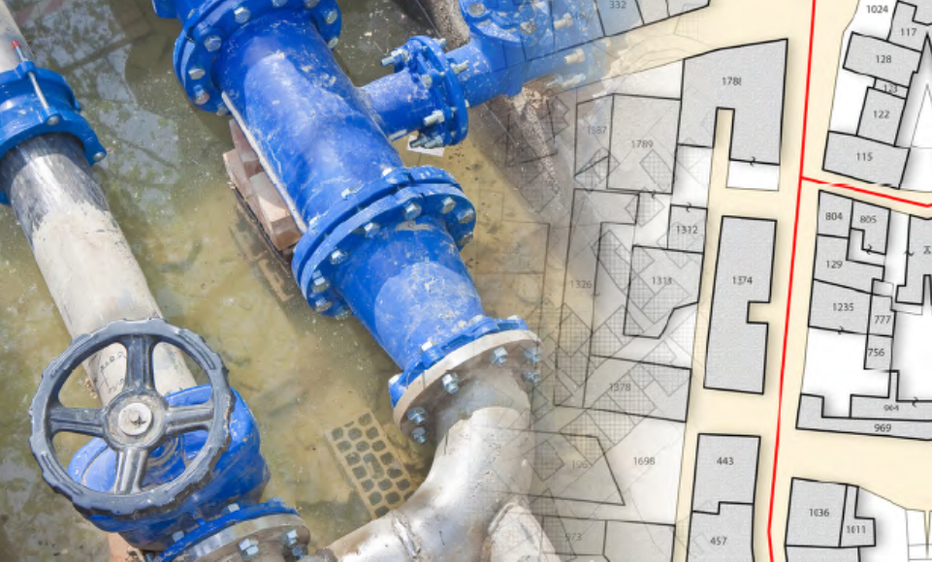

The Solution
The industrial sector has significantly improved maintenance strategies. While reactive maintenance remains suitable for non-critical assets, proactive asset maintenance planning is essential for addressing critical asset failures.
By analysing existing asset datasets, the water company adopted a data-driven approach to asset management. For example:
- Mapping the Network: The 110,000-kilometer pipe network was mapped, and critical scores were assigned to each segment based on factors such as soil conditions, property age, material type, pipe diameter, historical failure rates, asset conditions, and locations.
- Predictive Modeling: Failure models were developed using these variables, and simulations of the network were run repeatedly to achieve an 85-90% confidence rate. This enabled precise identification of high-risk assets and prioritised interventions.
- Real-Time Analytics: For assets with real-time data availability, PAM leveraged near real-time equipment and process data to predict failures with high accuracy and minimal false positives.
- Risk-Based Prioritisation: Consequence scoring was used to prioritize assets based on their risk exposure. Assets serving fewer than 10 people were assessed differently from those serving over 100,000, ensuring resource allocation aligned with potential impact.
This approach improved repair and replacement rates, delivering value-for-money capital and maintenance projects. Additional benefits included enhanced customer relations and trust.
Results
Key Benefits:
• Optimised Investment: Rationalizing renewal spending led to a 20% optimisation by deprioritising or deferring non-urgent investments.
• Enhanced Decision-Making: Risk analytics provided a comprehensive understanding of asset failure risks, enabling proactive interventions.
• Improved Customer Confidence: Efficient asset management boosted customer satisfaction and trust.

Key Findings from the Pilot
Preventive Asset Management plans include:
- Regularly assessing the asset system’s capability to meet changes in performance, population growth, climate change, and regulatory requirements over short, medium, and long terms.
- Exploring innovative techniques to address capability gaps (including assets and human resources) for delivering leading customer service.
- Defining and managing service risk through regular assessments of asset health and operational resilience.
- Making asset management decisions using a risk-based approach and balancing whole-life costs and benefits.
- Utilising robust asset information management systems for informed decision-making.
- Managing intervention costs, outputs, and targets within the constraints of the 5-year Asset Management Plan (AMP).
- Understanding the relationship between departmental activities across the asset lifecycle.
- Continuously reviewing and improving the effectiveness of processes and systems.
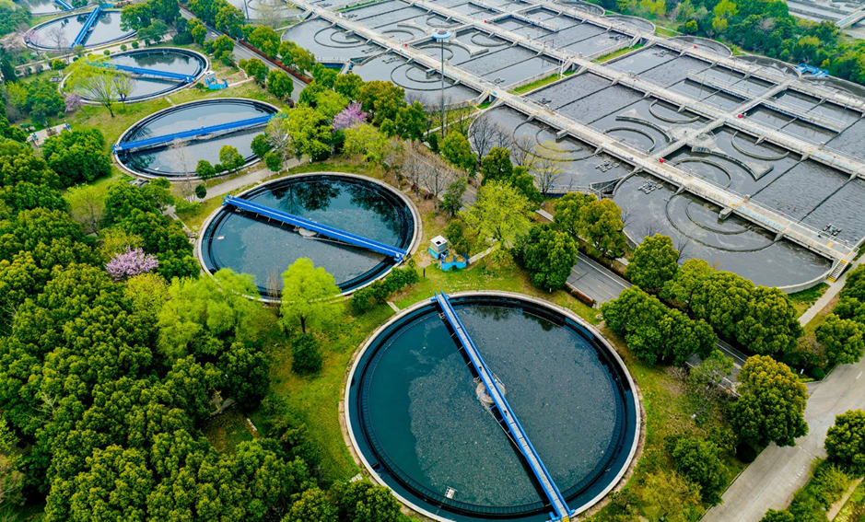

Knowledge and Skills
One-off Activities | Ongoing Activities
Scoping | Treatment process audit
Process modeling | Treatment work design
Network and pumping station audit | Treatment Asset Management Plans
Network modeling | Network Asset Management Plans
Network design | Project management
Civil engineering consultancy | M&E engineering consultancy
Real-World Examples
Utilities implementing Preventive Asset Maintenance (PAM) have seen measurable cost savings and improved operational resilience. For instance, Anglian Water adopted AI-powered BurstDetect and BlockageDetect systems to monitor rising mains and pumping stations. These systems generated over 2,000 early alerts, detected 50 bursts before pollution events occurred, and informed the rehabilitation of 42 critical rising mains. While specific cost savings aren’t publicly stated, this volume of water recovery would equate to hundreds of thousands of pounds annually in avoided water production and supply costs. (Ovarro, 2023).
Similarly, Thames Water integrated Samotics’ electrical signature analysis technology into their asset maintenance strategy to monitor submerged pumps. By detecting faults early and enabling condition-based maintenance, they prevented up to 30% of electrical-related pump failures. This reduced unplanned downtime and emergency repairs, lowering O&M expenditures and extending asset life - resulting in an estimated cost avoidance of over £700,000 annually in operational and maintenance expenditure (Samotics, 2021).
These examples support the broader financial rationale for predictive maintenance in water utilities—namely, shifting spend from short-term O&M budgets to long-term capital efficiency with lower customer impact.

Harvard Style References
Ovarro (2023) Anglian Water adopts Ovarro’s AI-driven wastewater solutions. Available at: https://ovarro.com/en/global/case-studies/anglian-water-adopts-ovarros-ai-driven-wastewater-solutions-/3/ (Accessed: 13 July 2025).
Samotics (2021) Thames Water selects Samotics as long-term predictive maintenance partner. Available at: https://samotics.com/news/thames-water-selects-samotics-as-long-term-predictive-maintenance-partner (Accessed: 13 July 2025).

